UMKC Fieldguide

David Scott

Awesome

**Revision History**

|  |  |  |
| --- | --- | --- |
| **Author** | **Date** | **Revision** |
| David Scott | 9/14/2012 | Initial Release |
|  |  |  |

Project Goals:

The purpose of the UMKC Fieldguide is to provide new students with the information they need to get around the campus and locations of interest specifically geared towards those students.

* Provide locations for food, parking, computer labs (specific to those available by major), buildings, restrooms and student lounges.
* Provide walking directions between the student’s current location and any of the above locations.
* Provide a complete directory for all faculty and campus departments including email and phone number

Project Scope:

The scope of the project for the semester will be for 3-4 of the main buildings on the Volker campus including Flarshiem, Royal, Student Union and Katz. Were the project to be completed after the semester was over, the included information would be for all buildings on campus, even Hospital Hill.

This project will include information between Volker Blvd & 54th Street and Troost Ave & Brookside Blvd.

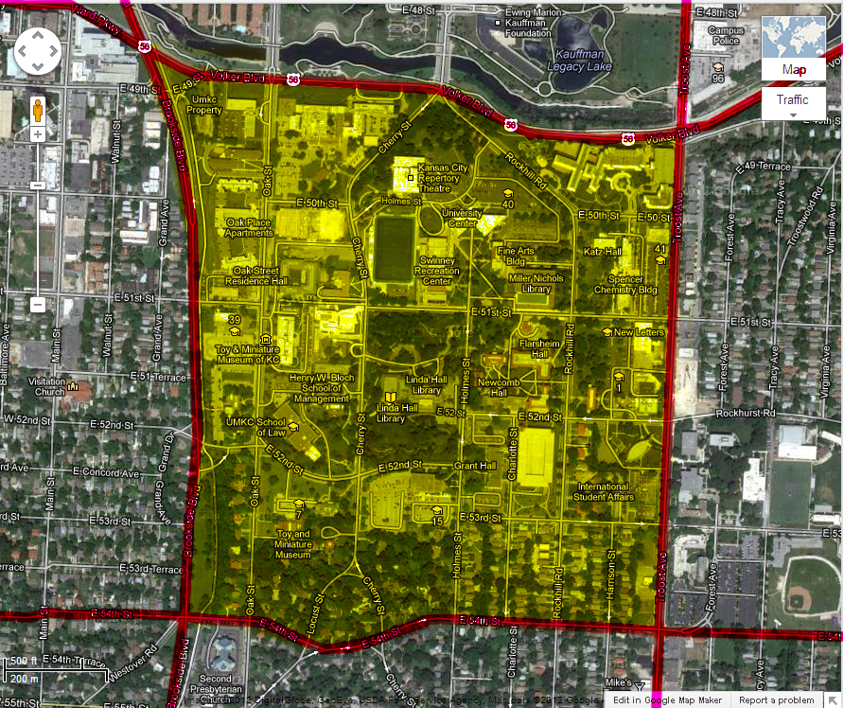

Essential Features (in order of priority):

* Locations of buildings
* Walking Directions from current location to provided location
* Locations of food (including vending machines)
* Locations of parking
* Locations of computer labs
* Locations of student lounges
* Locations of restrooms

Desirable Features (in order of priority):

* Faculty/Department directory
* Campus information beyond basic (campus history, places of interest on campus)
* Student Map – guide for new students ranging from application directions to applying for graduation. (info for this feature would include the info on the QuickGuide page on the UMKC website: <http://www.umkc.edu/quickguide/> )

Milestones:

* Recording all the needed locations
* Creating a database to store this information
* Create a Buildings locator
* Implement Walking Directions
* Create a Food/Parking/Labs/Lounge/

**Iteration 1**

Current release plan:

|  |  |  |  |  |
| --- | --- | --- | --- | --- |
| **Story ID** | **Story** | **Story Points** | **Priority** | **Status** |
| 1 | As a user, I’d like to find the locations of buildings on campus. | 5 | 2 | Started |
| 2 | As a user, I’d like to have a list of locations available to me to choose from. | 8 | 1 | Started |
| 3 | As a user, I’d like to see these locations on a map with information about the location. | 10 | 3 | Started |
|  |  |  |  |  |

Iteration #1 plan:

|  |  |  |  |
| --- | --- | --- | --- |
| **Story ID** | **Story / Task** | **Estimated**  **Hours** | **Actual**  **Hours** |
| 1 | As a user, I’d like to find the locations of buildings on campus. |  |  |
|  | Design UI for menu screen | 8 |  |
|  | Get locations for buildings around campus | 10 |  |
|  | Get app to find the user’s location | 2 |  |
| 2 | As a user, I’d like to have a list of locations available to me to choose from. |  |  |
|  | Create a table view to list information | 7 |  |
|  | Have each cell show the title, distance from user and building located in (if any) | 1 |  |
|  | Have the cells be selectable, but not editable | 3 |  |
| 3 | As a user, I’d like to see these locations on a map with information about the location. |  |  |
|  | Pinpoint user’s location to as accurate as possible | 1 |  |
|  | Create an annotation point for each of the locations | 7 |  |
|  | Place the annotation on a map | 2 |  |